**3 AUGUST 2024**

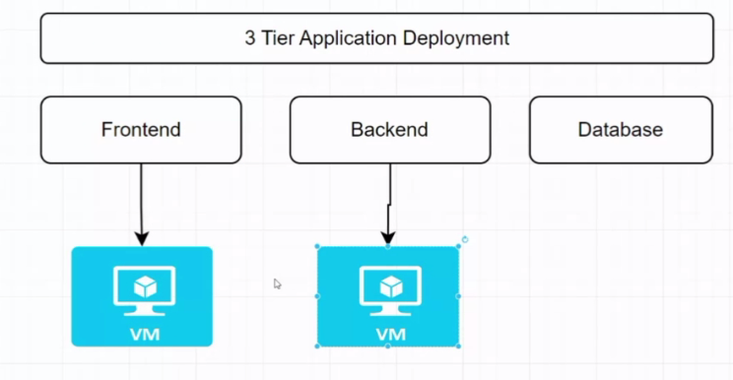

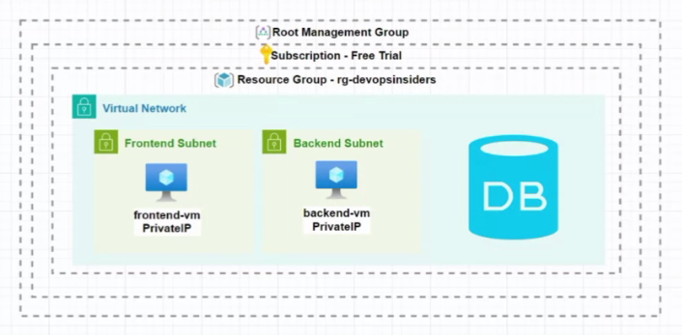

1) Using “azure-todo-app-terraform” from website

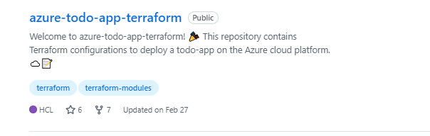

2) Make new project and do import repo as shown below

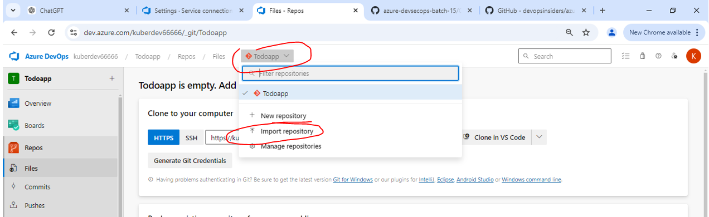

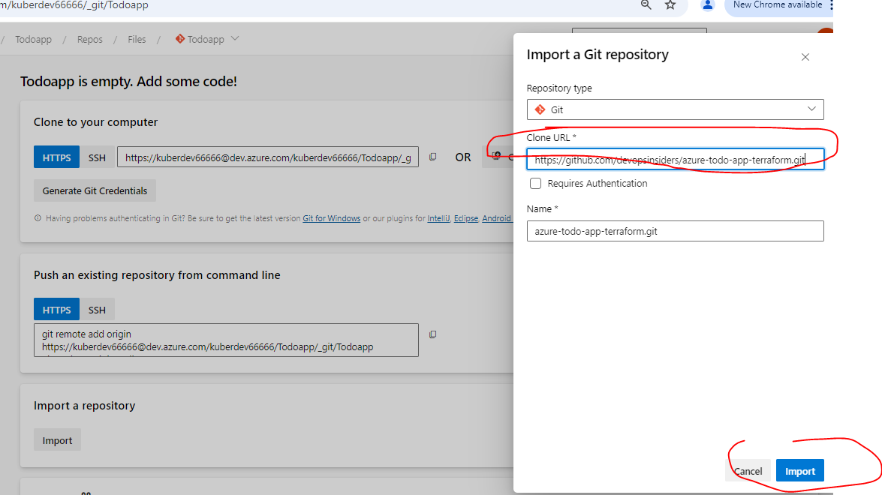

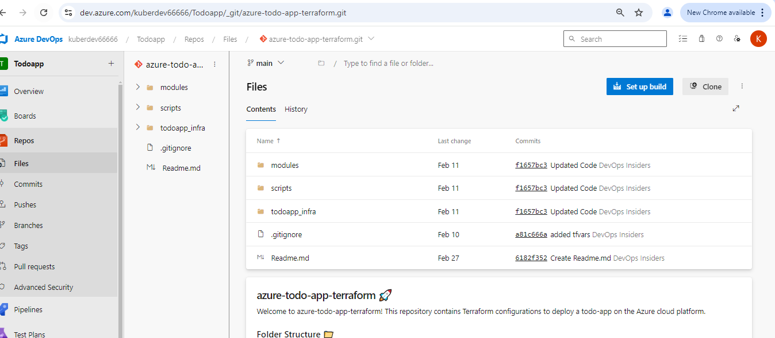

3) Now we will make pipeline to deploy this imported code

4) After making pipeline git clone the repo in our local and open with vs code

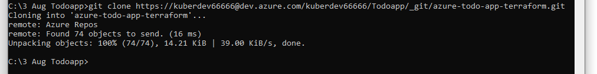

5) Now in vs code made changes and open terminal and perform below steps

i) git add .

ii) git commit -m “updated tfvars”

iii) git push

6) Now refresh dev.azure.com, which will show updated code in it

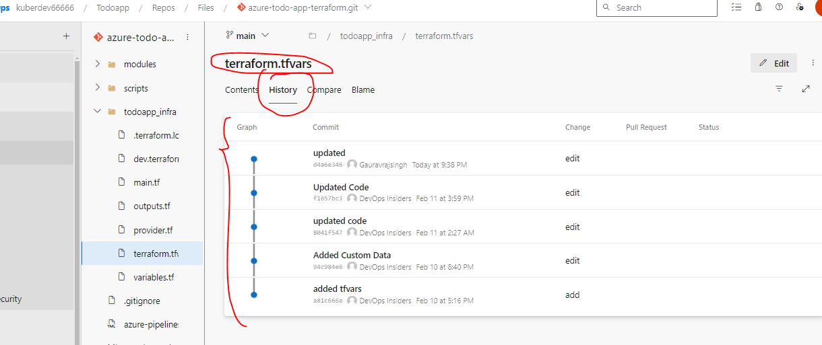

7)

**++++++++++++++++++++++++++++++++++++++++++++++++++++++++++++++++++++++++++++++++++**

8) Functions used in code

i) lookup

ii) ceil

iii) transpose

iv)

**++++++++++++++++++++++++++++++++++++++++++++++++++++++++++++++++++++++++++++++++++**

8a) So the flow is as below

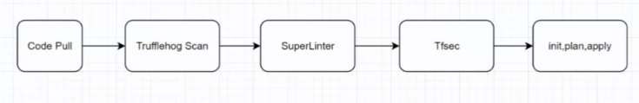

9) Now our pipeline is successful means our infra is successfully created to deploy application on it.

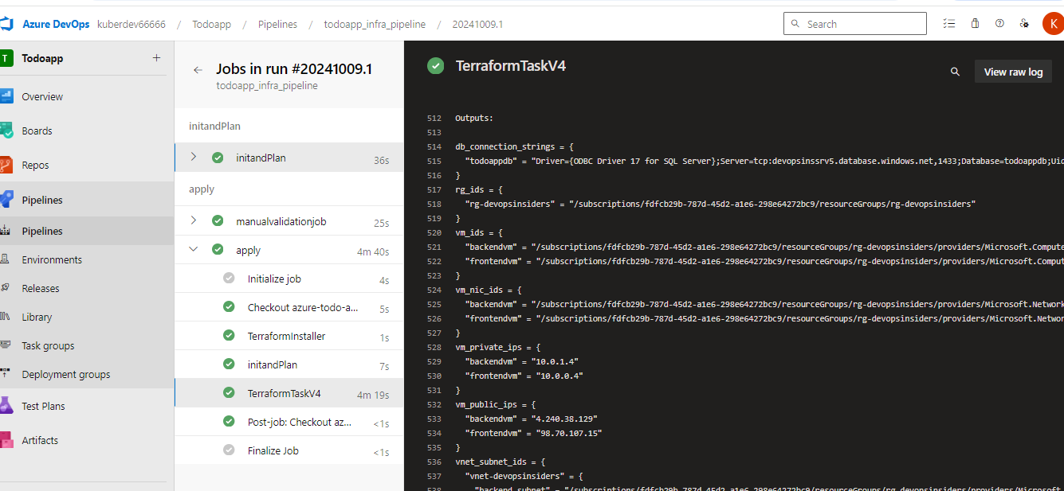

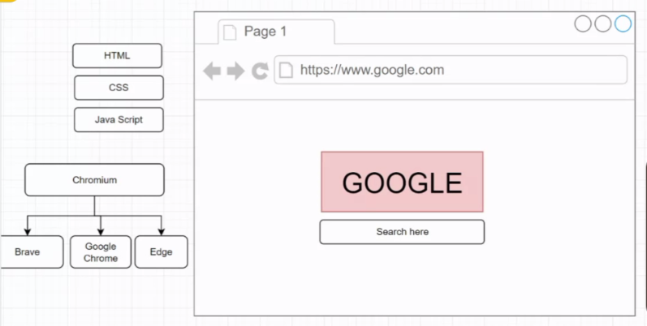

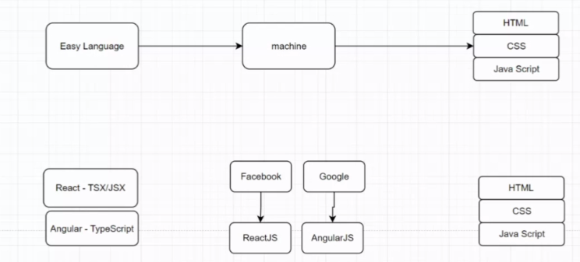

10) **BUILD PROCESS =** Conversation of code to a different format which is understandable by a browser is BUILD PROCESS.

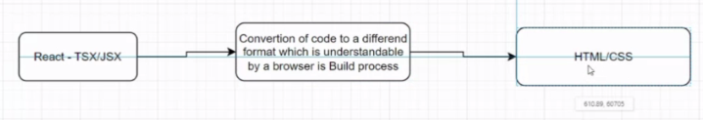

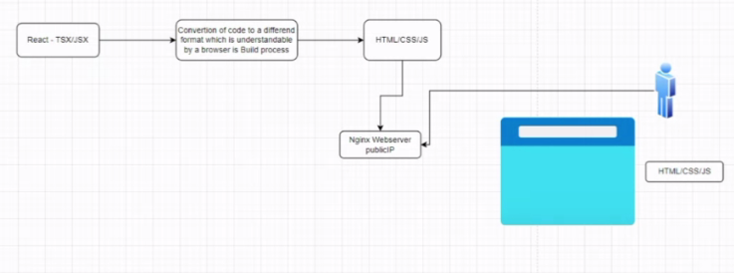

11) Now for deployment

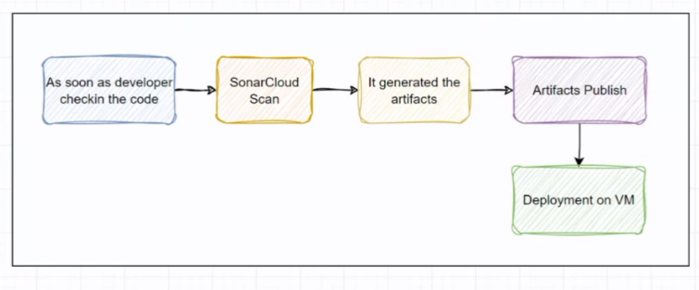

**++++++++++++++++++++++++++++++++++++++++++++++++++++++++++++++++++++++++++++++++++**

1) After this monolithic architecture end to end manual deployment will be completed

i) Landing zone with terraform pipeline

ii) nginx data script se khatam

iii) Pipeline deployment completed with this setup i.e. fronted and backend

iv) code quality completed by sonar cube

v) Unit test case alag team

vi) Vulnerability scan by checkmarks tool and checkov tool

vii) infrastructure vulnerability completed by tfsec

viii) Trufflehog se secret management completed

ix) Linting process completed by super linter

x)